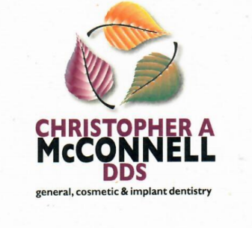

To the office of:

Address:

Phone: |  | Fax: |  | E-Mail:

has requested dental x-rays and records to be transferred to,

Christopher A. McConnell, DDS

200 W. County Line Road, Suite 240

Highlands Ranch, CO 80129

e-mail:cmccdds@gmail.com

303-791-6900

I authorize transfer of my x-rays and records to Dr. McConnell

Patient E-Signature: |  | Date:

cmccdds@gmail.com | 303-791-6900 phone | 303-791-7954 fax
Highlands Ranch Health Care Plaza | 200 W. County Line Road, Suite 240 Highlands Ranch, CO 80129
Fellow American College of Dentists |Fellow American Association of Hospital Dentists | Fellow Delta Sigma Delta

